- Download the standalone version from here and unzip to your local
https://github.com/jasmine/jasmine/releases
- Copy the TCS supplied source code in the same hierarchy as ‘src’
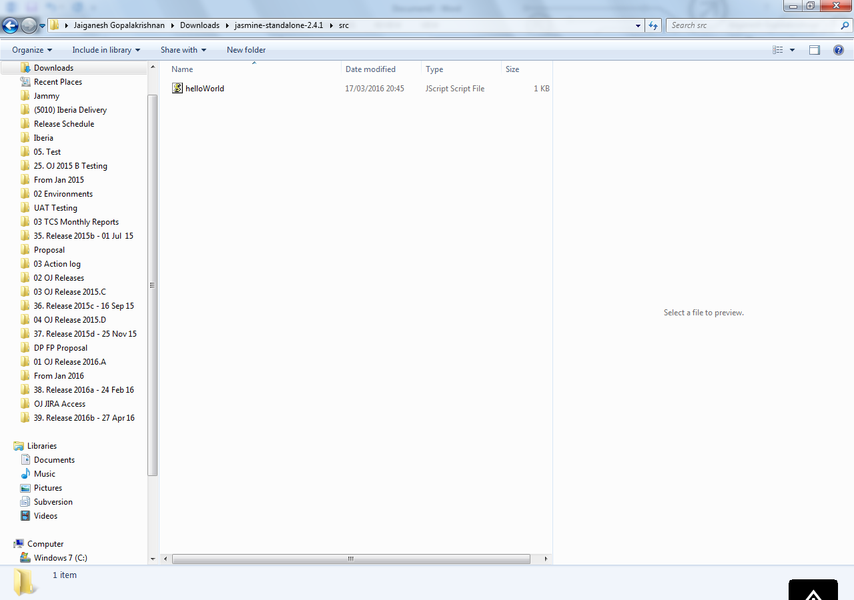

- Copy the TCS supplied test files into same hierarchy as ‘Spec’

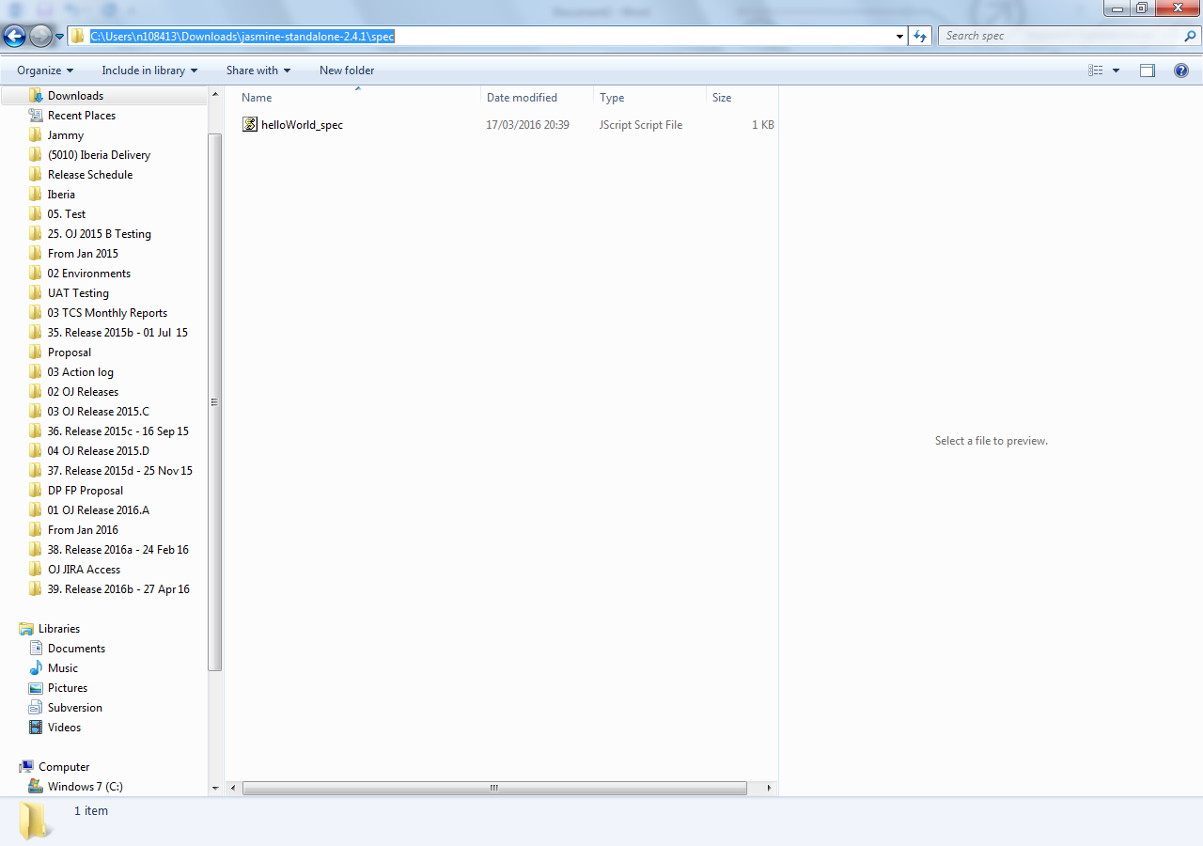

- Include the src and spec files in the SpecRunner.HTML
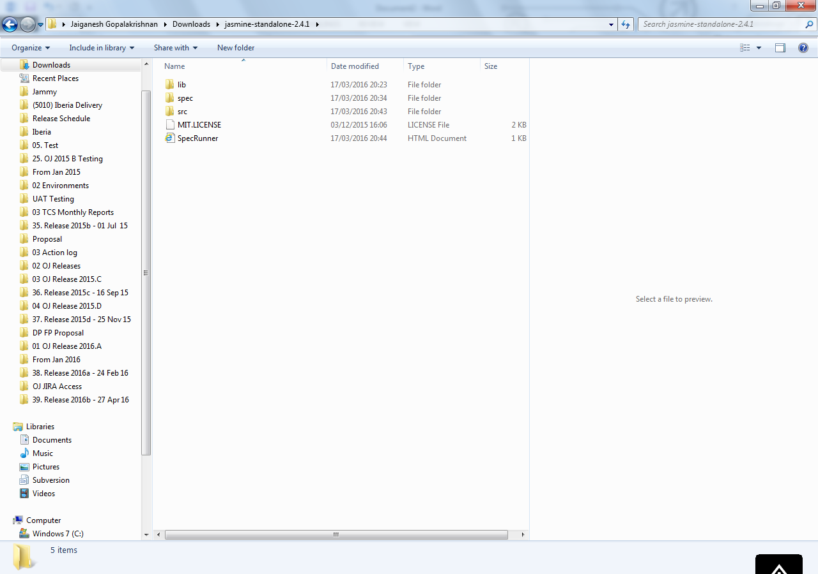
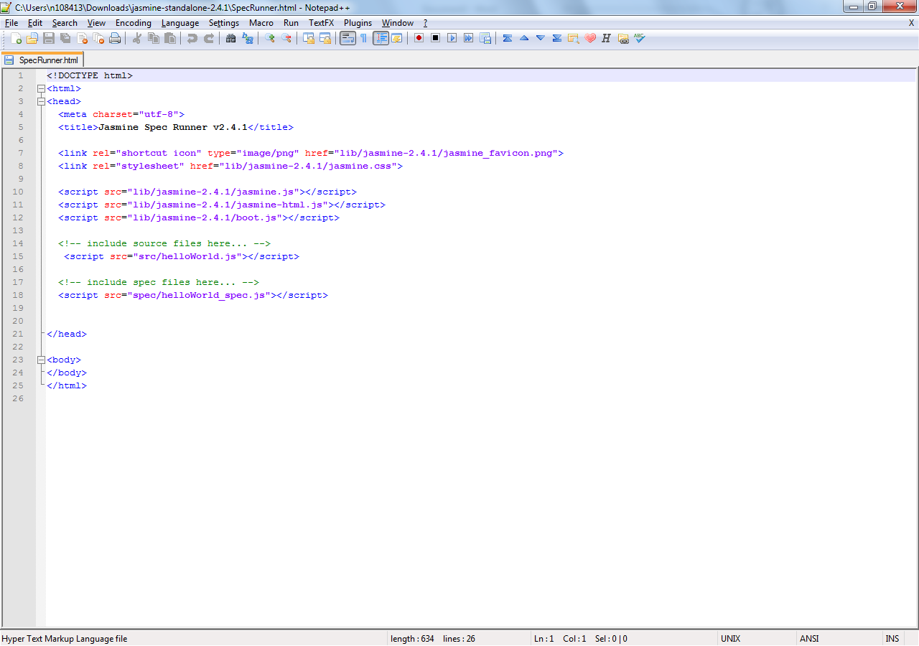
- Reload the SpecRunner.HTML to run the scripts and display the results

Download the master copy of jasmine with all utilities included from this location. This will help to run wider range of tests.
https://github.com/jasmine/jasmine
Detail about each functions can be found here
http://jasmine.github.io/2.0/introduction.html

Useful links
https://github.com/jasmine/jasmine/wiki
https://github.com/jasmine/jasmine/wiki/A-simple-project
http://tryjasmine.com/

